**Name: Bushra Farooq**

**Cms Id: 479973**

**Task 1**

#include <iostream>

#include<vector>

using namespace std;

int main() {

vector<int> v;

for(int i=1;i<=10;i++){

v.push_back(i);

}

cout<<"the elements of vector v are:"<<endl;

for(auto i=v.begin();i!=v.end();++i){

cout<< *i<<endl;

}

cout<<"elements of vector after replacing 5 with last element:"<<endl;

v.pop_back();

v.push_back(5);

for(auto i=v.begin();i!=v.end();++i){

cout<< *i<<endl;

}

return 0;

}

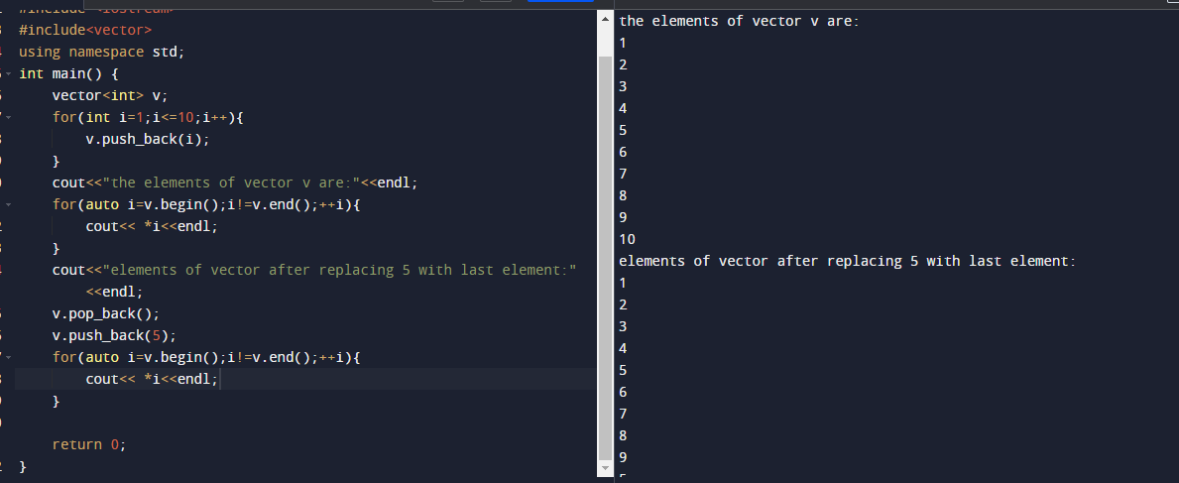

**Task2**

#include <iostream>

#include <vector>

#include <string>

using namespace std;

int main() {

vector <int> grade;

vector <string> name;

for(int i=0;i<=9;i++){

string n;

int g;

cout<<"enter the name:"<<endl;

cin>>n;

name.push_back(n);

cout<<"enter the grade:"<<endl;

cin>>g;

grade.push_back(g);

}

int mean,sum=0,median,mode;

for(int i=0;i<=9;i++){

sum=sum+grade[i];

}

mean=sum/10;

cout<<"the mean is:"<<mean<<endl;

median=(grade[4]+grade[5])/2;

cout<<"the median is:"<<median<<endl;

for(int i=0;i<=9;i++){

int count=0,compare;

for(int j=0;j<=9;j++){

if(grade[i]==grade[j]){

count++;

}

if(count>compare){

compare=count;

mode=grade[i];

}

}

}

cout<<"the mode is:"<<mode<<endl;

cout<<"the students with grades as mode is"<<endl;

for(int i=0;i<=9;i++){

if(grade[i]==mode){

cout<<name[i]<<endl;

}

}

return 0;

}

